ClothingStore ASP.NET Core MVC Application Documentation
1. Project Overview
The ClothingStore project is an ASP.NET Core MVC web application designed to help users efficiently manage a clothing retail store. The system supports full CRUD operations across multiple related entities. Users can manage Categories, Brands, Products, Customers, and Orders, all from a single platform.
The project demonstrates the use of MVC architecture, Entity Framework Core, ViewModels, Bootstrap styling, and Tag Helpers, meeting the technical requirements for a typical e-commerce management system.

2. Entities and Relationships
The application contains five main entities:
2.1 Category
- Properties:
  - CategoryId (PK)
  - Name
  - Description
  - CreatedDate
  - UpdatedDate
- Relationships:
  - One-to-many with Products (a category can have multiple products)
2.2 Brand
- Properties:
  - BrandId (PK)
  - Name
  - Country
  - EstablishedYear
- Relationships:
  - One-to-many with Products (a brand can have multiple products)
2.3 Product
- Properties:
  - ProductId (PK)
  - Name
  - Price
  - Size
  - Color
  - CategoryId (FK)
  - BrandId (FK)
- Relationships:
  - Belongs to one Category
  - Belongs to one Brand
  - Many-to-many with Orders (through OrderItems junction table)
2.4 Customer
- Properties:
  - CustomerId (PK)
  - FullName
  - Email
  - Phone
  - Address
- Relationships:
  - One-to-many with Orders (a customer can place multiple orders)
2.5 Order
- Properties:
  - OrderId (PK)
  - CustomerId (FK)
  - OrderDate
  - TotalAmount
- Relationships:
  - Many-to-many with Products via OrderItems junction table
2.6 OrderItems (junction table)
- Properties:
  - OrderItemId (PK)
  - OrderId (FK)
  - ProductId (FK)
  - Quantity
- Purpose: Implements many-to-many relationship between Orders and Products

3. MVC Structure
The project follows MVC architecture:
- Models: Represent entities with properties and navigation properties for relationships.
- Views: Strongly typed views for each entity, using Razor syntax. Includes Index, Create, Edit, Details, and Delete views.
- Controllers: Handle user requests for CRUD operations. Each entity has its own controller.
- ViewModels: Used where multiple entities or dropdowns are needed, e.g., creating an order requires selecting a customer and products.
Partial views are used for reusable components like alerts, navigation menus, and validation messages.

4. CRUD Operations
4.1 Categories
- Create, Read, Update, Delete categories with Bootstrap-styled tables and forms.
- Dropdowns for selecting related data where applicable.
4.2 Brands
- CRUD operations with proper navigation to related products.
4.3 Products
- Include details such as Name, Price, Size, Color (color picker used), Brand, and Category.
- Supports adding multiple products to Orders.
4.4 Customers
- Manage customer details like Full Name, Email, Phone, and Address.
4.5 Orders
- Orders linked to customers with a many-to-many relationship to products.
- Shows products in the order with quantity.
- Allows editing or removing products in an order.
Screenshots of each CRUD page should be included here for submission.

5. Database & EF Core
- Code-first migrations are used to create the database schema.
- Navigation properties enforce relationships.
- Foreign keys ensure data integrity between related entities.
- Sample migration command used:
Add-Migration InitialCreate
Update-Database

6. ViewModels
- OrderVM: Combines Customer selection and multiple Product selections for creating orders.
- CategoryVM, ProductVM: Used to populate dropdowns and display related data.
- Purpose: Allows strongly-typed views to work with multiple entities in a single form.

7. UI & Tag Helpers
- Bootstrap used for consistent layout and styling.
- Buttons: btn btn-primary, btn btn-danger, btn btn-success, etc., used for actions.
- Tables: table table-bordered table-striped table-hover for uniform styling.
- Validation: Data Annotations with asp-validation-for for error messages.

8. GitHub Collaboration
- One shared repository with all project files.
- Each team member contributes to at least one entity or feature.
- Commit history shows who added which feature or fixed bugs.
- README contains group member names and instructions for running the project.

9. ERD (Entity Relationship Diagram)
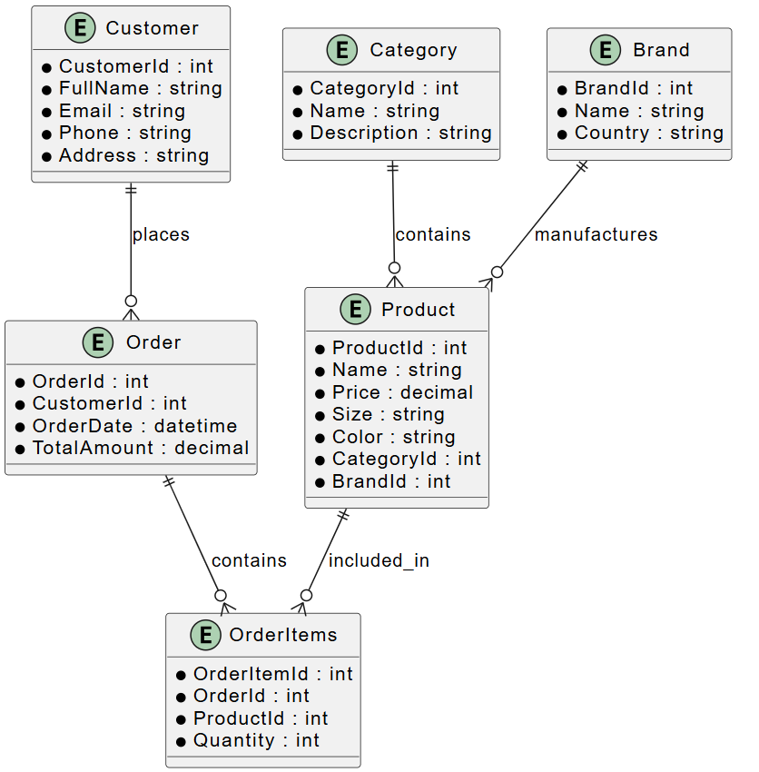
10. Screenshots
Include screenshots of the following pages:
- Home Page (Hero Section and navigation)
- Category CRUD pages
- Brand CRUD pages
- Product CRUD pages
- Customer CRUD pages
- Order CRUD pages

